# ****1、添加traefik helm仓库****

|  |
| --- |
| $ **helm repo add traefik https://helm.traefik.io/traefik**  $ **helm repo update** |

# **2、下载到本地**

|  |
| --- |
| $ **helm search repo traefik**  $ **helm pull traefik/traefik**  $ **tar xf traefik-10.20.1.tgz** |

# **部署Traefik**

**3.0 创建命名空间**

|  |
| --- |
| **kubectl create ns traefik-v2** |

**3.1 修改values**

|  |
| --- |
| #type: LoadBalancer  type: ClusterIP  ingressRoute:  dashboard:  enabled: false    ports:  traefik:  port: 9000  hostPort: 9000  exposedPort: 9000  expose: true  protocol: TCP  web:  port: 8000  hostPort: 80  expose: true  exposedPort: 80  protocol: TCP  websecure:  port: 8443  hostPort: 443  expose: true  exposedPort: 443  protocol: TCP      添加  additionalArguments:  - "--serversTransport.insecureSkipVerify=true"  - "--api.insecure=true"  - "--api.dashboard=true"      或者简单点  直接完整配置如下  ==================================  service:  type: ClusterIP    ingressRoute:  dashboard:  enabled: false    nodeSelector:  kubernetes.io/hostname: k8snode1    ports:  web:  hostPort: 80  websecure:  hostPort: 443  traefik:  port: 9000  hostPort: 9000  exposedPort: 9000  expose: true    additionalArguments:  - "--serversTransport.insecureSkipVerify=true"  - "--api.insecure=true"  - "--api.dashboard=true" |

**3.2 部署**

|  |
| --- |
| $ **helm install traefik traefik/traefik -f values.yaml -n traefik-v2** #部署    其他命令  $ **helm upgrade traefik traefik/traefik -n traefik-v2** #更新  $ **helm uninstall traefik -n traefik-v2** # 卸载 traefik    #查看状态  $ **helm list -n traefik-v2**  NAME NAMESPACE REVISION UPDATED STATUS CHART APP VERSION  traefik traefik-v2 1 2022-06-07 15:05:58.300911179 +0800 CST deployed traefik-10.20.1 2.7.0    $ **helm status traefik -n traefik-v2**  NAME: traefik  LAST DEPLOYED: Tue Jun 7 15:05:58 2022  NAMESPACE: traefik-v2  STATUS: deployed  REVISION: 1  TEST SUITE: None |

# **4 创建路由规则（2选1）**

**4.1原生Ingress路由规则**

|  |
| --- |
| cat >  traefik-ingress.yaml <<  apiVersion: networking.k8s.io/v1  kind: Ingress  metadata:  name: traefik-dashboard-ingress  namespace: traefik-v2  annotations:  kubernetes.io/ingress.class: traefik  traefik.ingress.kubernetes.io/router.entrypoints: web  spec:  rules:  - host: traefik.ingress.cn  http:  paths:  - pathType: Prefix  path: /  backend:  service:  name: traefik  port:  number: 9000  EOF |

**4.2 使用CRD方式配置路由规则**

|  |
| --- |
| cat > traefik-ingressRoute.yaml << EOF  apiVersion: traefik.containo.us/v1alpha1  kind: IngressRoute  metadata:  name: traefik-dashboard-route  namespace: traefik-v2  spec:  entryPoints:  - web  routes:  - match: Host(`traefikroute.ingress.cn`)  kind: Rule  services:  - name: traefik  port: 9000  EOF |

**namespace: traefik-v2 #要和traefik ingress所在的命名空间一致，就可以正常访问，**

**如：http://traefikroute.ingress.cn/dashboard/#/**

**否则访问需要添加expose里设置的端口；如http://traefikroute.ingress.cn:9000/**

# **5 访问**

|  |
| --- |
| http://traefik.ingress.com  http://traefik.ingress.com/dashboard |

# **6 验证**

### **暴露HTTP服务**

|  |
| --- |
| #创建pod和svc  **cat > whoami.yaml << EOF**  ---  apiVersion: v1  kind: Pod  metadata:  name: whoami  labels:  app: whoami  spec:  containers:  - name: whoami  image: traefik/whoami:latest  ports:  - containerPort: 80  ---  apiVersion: v1  kind: Service  metadata:  name: whoami  spec:  ports:  - port: 80  protocol: TCP  targetPort: 80  selector:  app: whoami  type: ClusterIP  **EOF**    ==========================  创建一个路由规则，使外部可以访问    **cat > whoami-ingressroute.yaml << EOF**  apiVersion: traefik.containo.us/v1alpha1  kind: IngressRoute  metadata:  name: whoami-route  spec:  entryPoints:  - web  routes:  - match: Host(`whoami.ingress.cn`)  kind: Rule  services:  - name: whoami  port: 80  **EOF** |

浏览器访问  whoami.ingress.cn

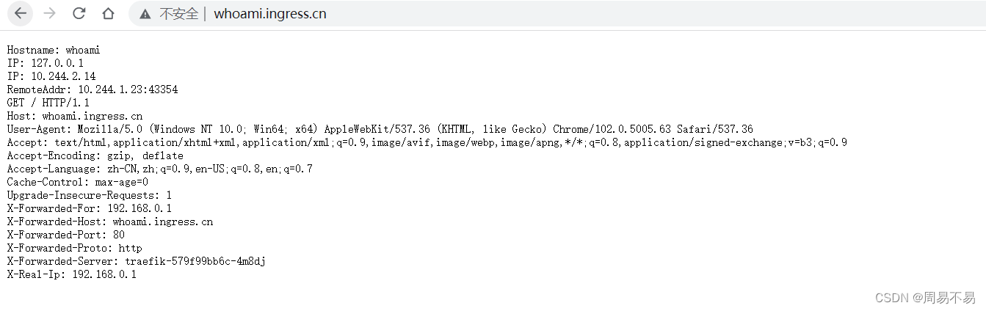

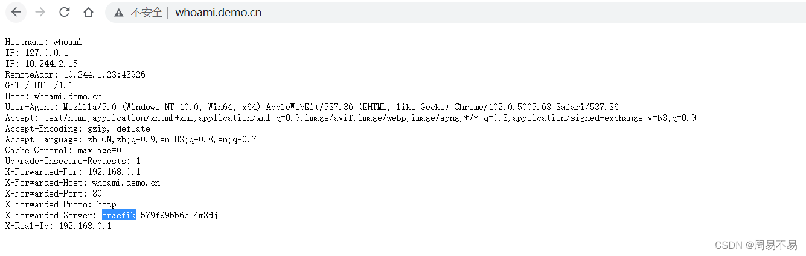

个人总结：

1. 其他通过traefik代理的资源应用pod,service并不需要与traefik在同一个命名空间，也就是命名空间对traefik代理来说并没有限制

**容器的网络访问不区分命名空间（kubernetes ns）**

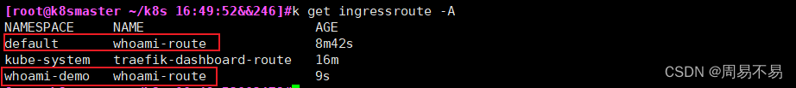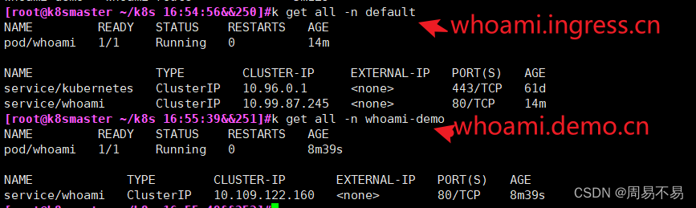

如以上两个实例都不在traefik ingress的命名空间里

1. 但是部署实例的****pod service 路由规则**** 都需要在同一个命名空间里

<http://wjhsh.net/hacker-linner-p-13632813.html> 主要参考values.yaml配置

<https://www.modb.pro/db/162128> 主要参考ingress路由规则whoami实例

<https://blog.51cto.com/u_15077560/2583980> 主要参考参数含义